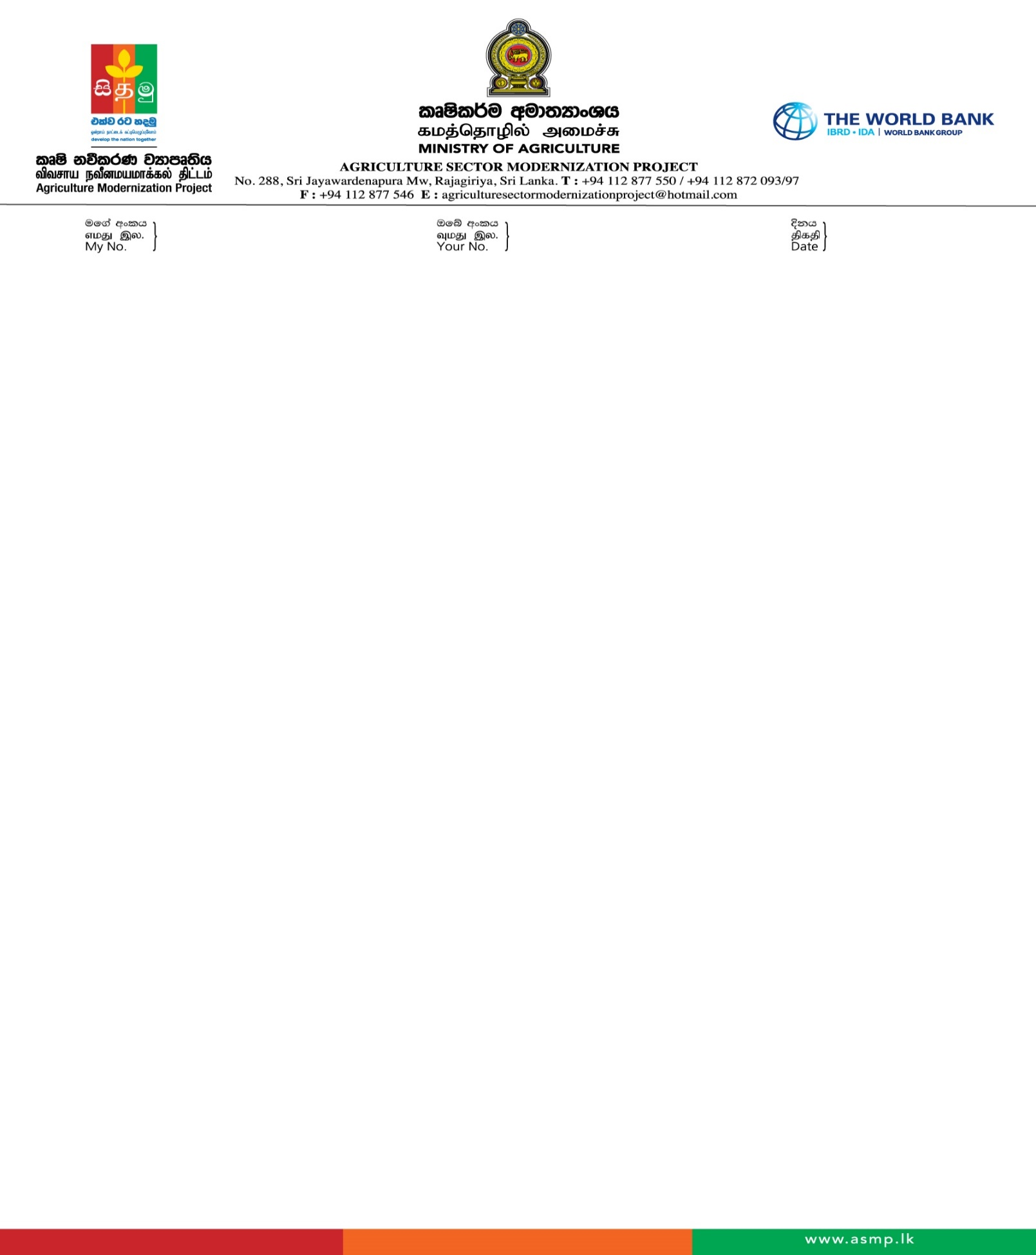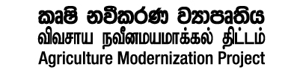 

***Ministry of Agriculture***

***A SM Project – IDA Credit No: 5873 LK***

**Democratic Socialist Republic of Sri Lanka**

**Agriculture Sector Modernization Project - Ministry of Agriculture & Plantation Industries**

**IDA Credit No: 5873 LK**

**Invitation for Individual consultants**

**Hiring of a short Term Individual Consultant to conduct the beneficiary survey covering all Project Districts to have a final tracking of the indicators in the project result framework and to have a project end-line analysis against the baseline of Component 2, Agriculture Sector Modernization Project.**

**Procurement No; Lk-MOA-PMU-428593-CS-INDV**

1. The Democratic Socialist Republic of Sri Lanka has received a Credit from the International Development Association (IDA) of the equivalent of US$ 125.00 million towards the cost of the Agriculture Sector Modernization Project (ASMP), of which US$ 64.23 million has been allocated for the implementation of Component 2 under MOA in the participating provinces in the seven project districts supported by IDA that is Jaffna, Mullaitivu, Ampara, Monaragala, Anuradhapura, Polonnaruwa and Matale.
2. An approximately additional financing of Euro 23.13 million has been granted by the European Union (EU) through WB to the ASMP to support the establishment of ATDPs in five new districts, increasing the total number of project districts to 12 in the five project provinces. The new districts are Kilinochchi, Vavuniya, Ampara, Badulla, and Kandy.
3. The selected Consultant for the above consultancy is expected to **conduct the beneficiary survey covering all Project Districts to have a final tracking of the indicators in the project result framework and to have a project end-line analysis against the baseline of Component 2.**
4. The Chairman of the Ministry Consultancy Procurement Committee – ASM Project now invites experts to send the updated Curriculum Vitae to provide the consulting service of Hiring an Individual Consultant to conduct the beneficiary survey covering all Project Districts to have a final tracking of the indicators in the project result framework and to have a project end line analysis against the baseline of Component 2.More details on the consultancy are provided in the Terms of Reference publish in the ASMP web “https://www.asmp.lk/advertisement”
5. A Consultant will be selected under the Selection of Individual Consultants basis and procedures described in this TOR, in accordance with the policies of the International Development Association (IDA) detailed in the Guidelines - Selection and Employment of Consultants by World Bank Borrowers which can be found at the following website: [www.worldbank.org/procure](http://www.worldbank.org/procure).

Please be kind enough to send a CV with the price proposal (with a breakdown of the Price proposed) in a separate sheet to the following address by post or by hand delivery on or before 2.00 pm, 06th of September 2024. Please Indicate “**Individual Consultant** **to conduct the beneficiary survey covering all Project Districts to have a final tracking of indicators”** on the left hand top corner of the envelope.

Further Clarification can be obtained from the procurement specialist ASM Project TP +94112877546 Ex211

Chairman

Ministry Consultancy Procurement Committee

Agriculture Sector Modernization Project

Ministry of Agriculture

No 123/2, Pannipitiya Road, Battaramulla

Email:[agriculturesectormodernizationproject@hotmail.com](mailto:agriculturesectormodernizationproject@hotmail.com),

**23/08/2024**